Teacher Guide for Grade 5

SECTION A : The rivalry between two 18th century superpowers

Competency 1  To understand the organization of a society in its territory  - Situates the society and its territory in space and time  - Makes connections between assets and limitations of the territory and the organization of society | 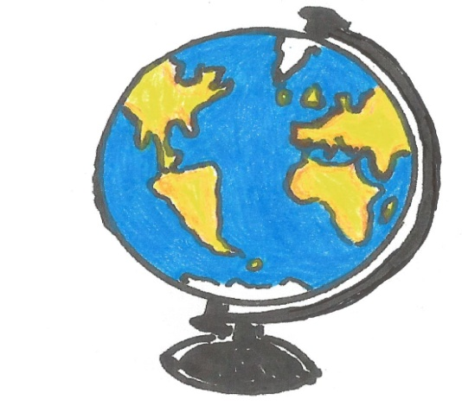  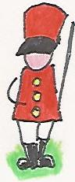
PoL
E. Canadian Society around 1820
- Location of the society in space and time
- Locates on maps with different scales the territory occupied by Canadian society: St. Lawrence River and the Great Lakes lowlands
- Elements of the society that affect the organization of the territory
  - Demographic situation
Describes the composition of the population; Native peoples, Canadiens and English
IO * Situates in time *Establishes facts
Techniques
Interprets simple maps Interprets tables Interprets maps Interprets illustrated documents

ACTIVITIES - SECTION A
TIMES OF TURMOIL
A (Cover) Rivalry between Great Britain and France
A1. British and French Territories
A2. Areas of Conflict
A3. North America before the Conquest
A4. and A5. Historical Texts
A6. Venn Diagram
A7. The British Plan of Attack on New France
A8. The Three Biggest French Settlements in North America
A9. The Bombardment of Quebec
A10. and A11. The Two Armies
A12. The Battle of the Plains of Abraham (1759)
A13. The Attack on Quebec
A14. The Capitulation of Montreal (1760)
A15. The War Ends...The Peace Treaty of Paris (1763)

SECTION A (cover)– THE RIVALRY BETWEEN GREAT BRITAIN AND FRANCE – 18th century
Teaching suggestions  Section A covers the historical period from before the Conquest (around 1750) up to and including the 1763 Treaty of Paris.  Both Great Britain and France were the undeniable European super powers of the 18th century. The acquisition of territory anywhere in the world was a boosting to their status claim, hence the urge of conquering new lands. | 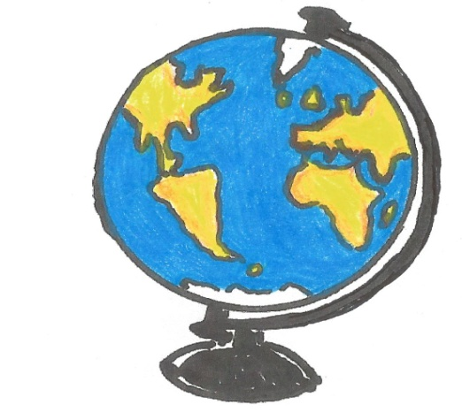

SECTION A1 – BRITISH AND FRENCH POSSESSSIONS (18TH CENTURY)
Teaching suggestions  Allow students to consult atlases or the Internet in their quest to complete A1 and A2. Although the main objective should be the regions relevant to 18th century North American history (e.g. New France, Thirteen Colonies, Great Britain, France, Australia, India, Caribbean islands, South Africa) other parts of the world should also be considered (the oceans, the continents...) | BRITISH AND FRENCH TERRITORIES IN THE 18TH CENTURY

SECTION A2 – AREAS OF CONFLICT
Teaching suggestions  The areas of conflict are easily identifiable. It is where the same red and blue numbers in A1 are placed side by side, that is around New France, the Caribbean Islands and eastern India. | AREAS OF CONFLICT BETWEEN THE FRENCH AND THE BRITISH IN THE 18TH CENTURY

SECTION A3 – NORTH AMERICA BEFORE THE CONQUEST (around 1750)
Teaching suggestions

Finished maps at right…

SECTION A4 – TEXT 1 NEW FRANCE TOWARDS 1745
Teaching suggestions  In slides A4 and A5, students should look for information on the two regions related to:  - Geographical situation  - Population  - Language and religion  - Economic activities  - Defence  Economics - is the way a society manages what it produces. (‘Manages’ here means how a country distributes, consumes and exports what it produces) | 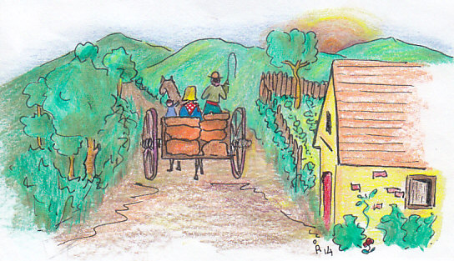

SECTION A5 – TEXT 2 THE THIRTEEN COLONIES
Teaching suggestions  Refer to slide A4.  (Rupert’s Land was a British territory in British North America, which was owned by Hudson Bay Company for two hundred years, from 1670 to 1870.) | 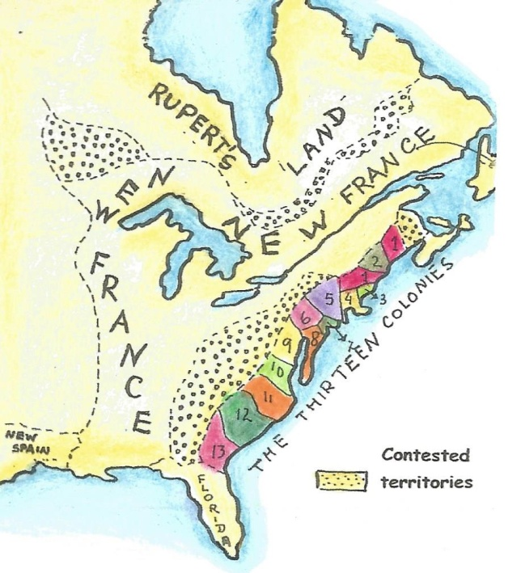

SECTION A6 – VENN DIAGRAM

Teaching suggestions  Answers to Venn at right… | New France  A, D, G, H, I  The Thirteen Colonies  B, C, F  Intersection  E, J, K

SECTION A7 – THE BRITISH PLAN OF ATTACK ON NEW FRANCE
Teaching suggestions  Students should be able to identify the St. Lawrence River, the mouth of the river and the gulf of the St. Lawrence, in order to understand the strategic importance of Louisbourg for France. | 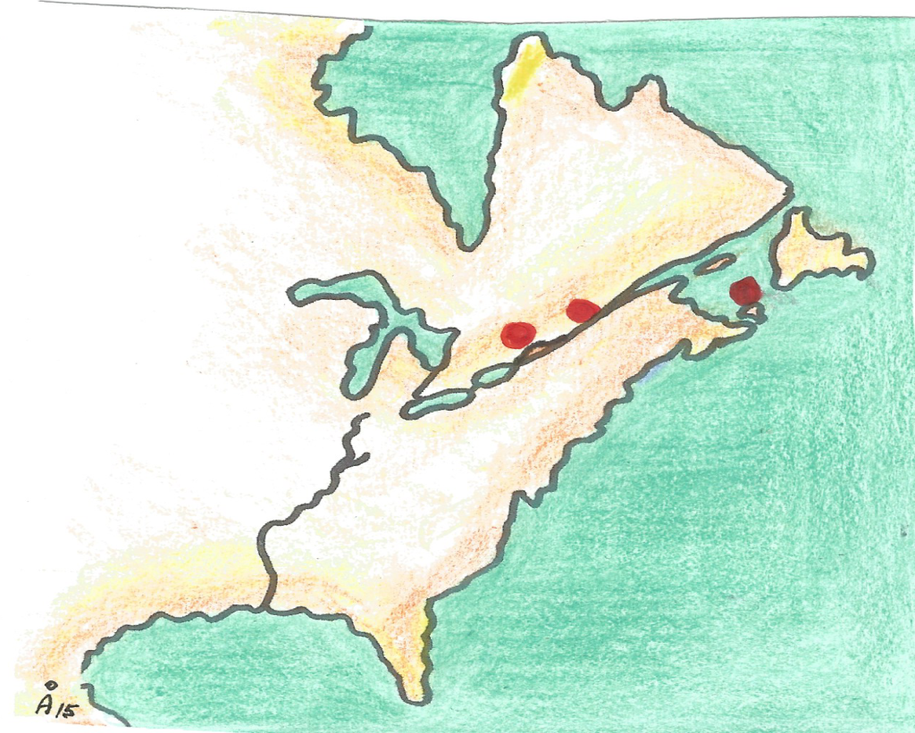  Montreal  Louisbourg  Quebec

SECTION A8 – THREE BIGGEST FRENCH SETTLEMENTS IN NORTH AMERICA IN THE 18TH CENTURY
Teaching suggestions  Allow some 10 minutes for the students to discuss, in groups of three, what were the similarities and the differences among the three French settlements. (One settlement was by the seaside, Louisbourg, and the other two were built on a river bank. Quebec has a steep cliff which could be used as a line of defence if attacked from the river; Montreal appears to be fairly flat along the riverside with a small elevation in the background. | a. All settlements were hilly and built near water (Louisbourg by the seaside, while Quebec and Montreal were built on the banks of the St. Lawrence River)  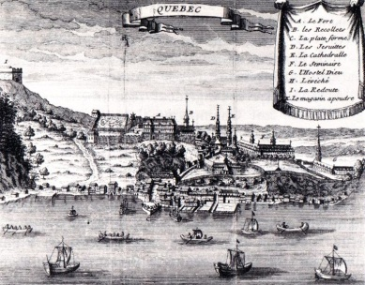  b. Louisbourg was heavily fortified against intruders. It protected the Gulf and the mouth of the St. Lawrence River, which was the entrance to New France.  c. Quebec was the seat of the government of New France, so if the city was attacked and defeated, there would be no government and New France would collapse.  d. Montreal capitulated because after the defeat of Quebec and Louisbourg, it had little chance of winning against the British. It would be impossible to get reinforcements from France, as they would have to come down the St. Lawrence which was under British control at the time.

SECTION A9 – THE BOMBARDMENT OF QUEBEC CITY
Teaching suggestions  Allow students to view the illustration to identify the ravages of war before starting the activity.  The students’ diverse responses might just surprise one.  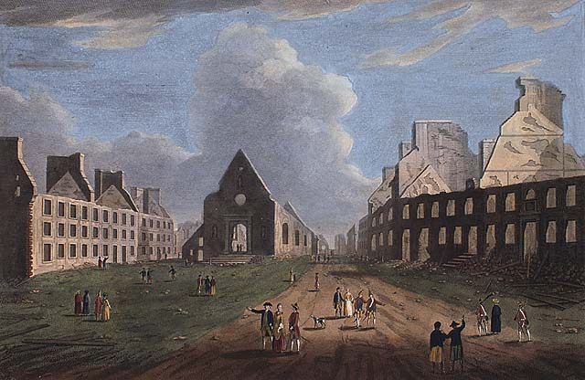 | Possible answers  1  i. all buildings, including the church, are without ceilings  ii. houses are but skeletons of their former selves, due to the bombardment  iii. people are strolling around looking at the ravages of war, while there is a total absence of normal urban activity.  2  Wolfe bombarded Quebec City, because it would be the most effective way of defeating the French presence in North America. It was in Quebec where the government sat, and without it the colony could not function.

SECTION A10 – THE TWO ARMIES
Teaching suggestions | 1.  Total number of French fighters (soldiers, militia and First Nation) = 3 800  Total number of British fighters (soldiers) = 4426  2.  No. It appears that the British had a better chance as all their fighters were professional soldiers.

SECTION A11 – STRENGTH AND WEAKNESSES
Teaching suggestions | STRENGTHS WEAKNESSES  1. All fighters were professional soldiers 2. British soldiers were well equipped 3. General Wolfe opted for a surprise attack on Quebec, making it difficult for the French to counterattack. 1. They had to carry all their ammunition up a cliff in the darkness of night and then prepare for battle.  1. The French army knew the terrain well 2.They had the support of the First Nations who were excellent fighters 1. The First Nations and Canadien militia were poorly equipped. They lacked rifles, that is, 1 800 of the fighters were poorly equipped. 2. Those mentioned in 1, had no training on open battle techniques

SECTION A12 – THE PLAN OF THE BATTLE OF ABRAHAM
Teaching suggestions  Enlarge the illustration until it covers the Smart board completely.  Point out the characteristics of the terrain where the Battle of the Plains of Abraham took place.  - Only by climbing the cliff could the British position themselves for battle.  - The red dotted line divides the British and French positions. On which side would the French be? Obviously on the right hand side in order to defend the Quebec settlement further down but also on the right.  - The plains are surrounded by bushes. It was there where the militia and the First Nations hid attacking the British from the side.  (The battle of the Plains of Abraham lasted only 15 minutes, 58 British soldiers were killed,116 French soldiers died ) | 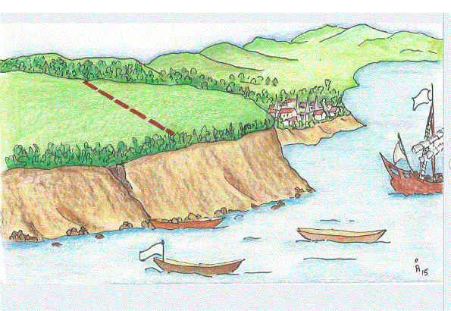

SECTION A13 – THE ATTACK ON QUEBEC
Teaching suggestions  Allow time for students to study the image. They should conclude that all ships are British and that the British army is disembarking to climb the steep cliff. | 1. The British are climbing the cliff near the Plains of Abraham and there are several rowing boats full of British soldiers approaching the cliff. According to statistics, 4426 British soldiers had to pass by the cliff to battle the French on the Plains.  2. Because it was where the New France government had its head quarters.  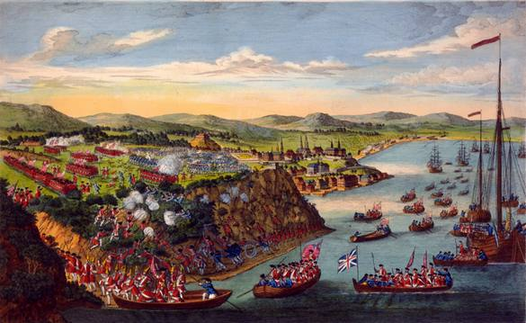

SECTION A14 – THE CAPITULATION OF MONTREAL
Teaching suggestions  Allow students to study the illustration before starting the activity and ask them, for example:  - How do you differentiate between the British and French soldiers in this illustration?  - What other group of people can you identify?  - What ceremony might this illustration depict, considering it is 1760? | 1. It cannot be Quebec because the buildings are intact. Montreal was never bombarded.  4. They are probably handing over the documents of the surrender of Montreal to the British authorities.  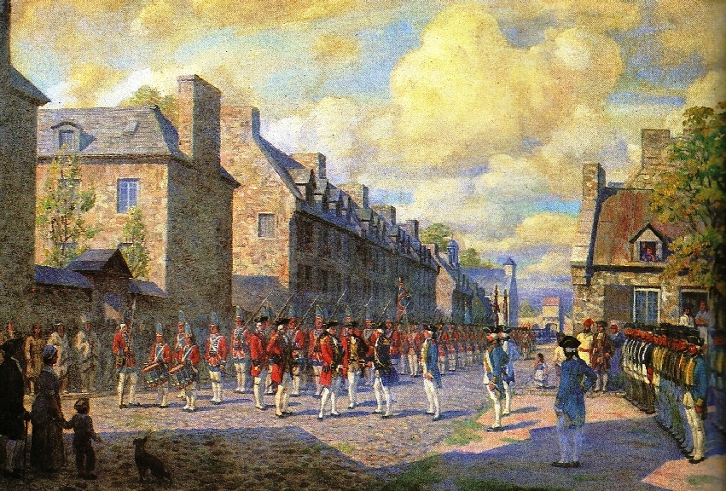

A15 – THE WAR ENDS ... THE TREATY OF PARIS 1763
Teaching suggestions

The map shows the extent of territory gained by the British after the conflict with France in North America. Great Britain was, for awhile, in total control of North America that is the east coast, around the Great Lakes, down the Mississippi Valley to the Gulf of Mexico. Soon, however, the American settlers would revolt and declared their independence from Britain.

